Test # 163
Instrument Name Consistometer
Instrument Type Consistometer
Test Start 03/02/01 10:50
Test Stop 6:05:19
Well ID # KHVALYNSKAYA #3
Customer LUKOIL
Cement Class G
Additives 1.25%SMS+1.25%TC-101+0.7%TR-1+Defoamer
Cement Mfr DYKERHOFF
BHCT 75
BHST 100
Density 1450
Fluid Loss
Job Type 340MM CSG
Comments MPa: 35(120min); T: 75C(120min), field water

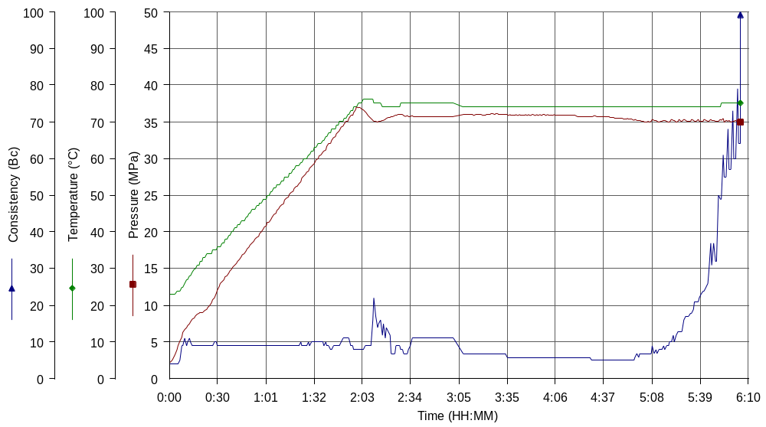

Test # 170
Instrument Name Consistometer
Instrument Type Consistometer
Test Start 04/02/01 19:41
Test Stop 12:38:56
Well ID # KHVALYNSKAYA #3
Customer LUKOIL
Cement Class G
Additives 0.85%TR-1+1.25%SMS+1.25%TC-101+Defoamer
Cement Mfr DYKERHOFF
BHCT 75
BHST 100
Density 1450
Fluid Loss
Job Type 340MM CSG
Comments MPa: 35(120min); T: 75C(120min), field water

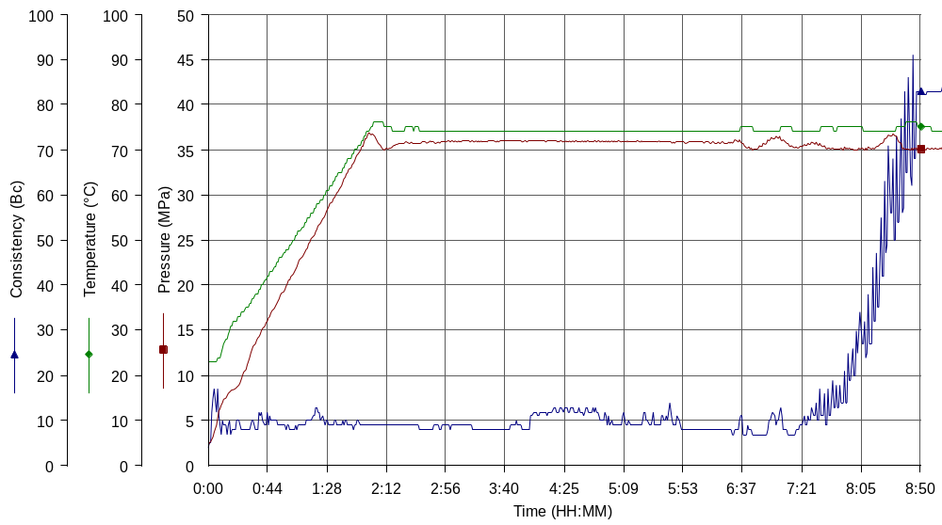

Test # 168
Instrument Name UCA Left
Instrument Type UCA
Test Start 04/02/01 16:49
Test Stop
Well ID # KHVALYNSKAYA #3
Customer LUKOIL
Cement Class G
Additives 0.85%TR-1+1.25%SMS+1.25%TC-101+Defoamer
Cement Mfr DYKERHOFF
BHCT 75
BHST 100
Density 1450
Fluid Loss
Job Type 340MM CSG
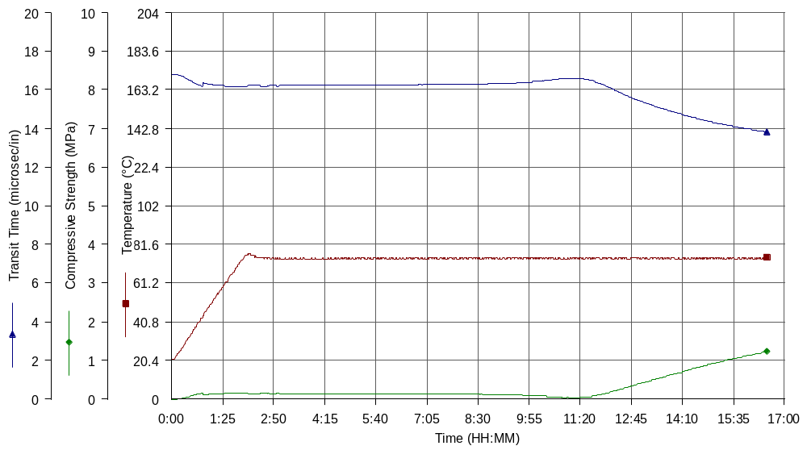
Comments T: 75C(120min)

